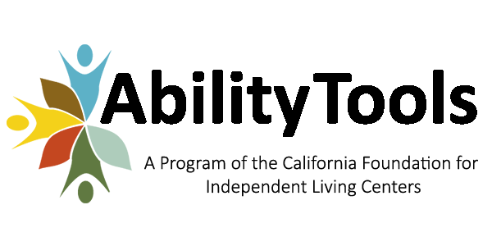
Device Lending and Demonstration Center Budget Instructions

CONTRACT NUMBER: 2018-DLDC-XX

CONTRACT TERM: December 1, 2018 through September 30, 2019

TOTAL CONTRACT AMOUNT: Actual costs up to $19,250. No unused funds may be carried forward to the next contract term, including extensions and renewals.

BUDGET INSTRUCTIONS: Attachment 1

PERSONNEL: Line P-1 thru P-4: Enter name of employee, job title and percent FTE. (6 hours per week = 15% etc.), budgeted salary and hourly rate for each staff person (Subtotal Direct Personnel Budgeted hours will automatically calculate).

Subtotal Salaries: Adds Lines P-1 through P-4.

Line P-5: Enter the dollar amount of total benefits & payroll taxes.

Subtotal - Direct Personnel Budget: Will automatically calculate Subtotal Direct Personnel Budget and Payroll Taxes & Benefits.

DIRECT OPERATING BUDGET: Line O-1 through O-4: Do not change the description. Enter total dollar amount if any. Line O-1 has a minimum of $300.00 for Postage & Shipping. Line O-2 has a minimum of $1,000.00 for equipment purchases. Please note that for lines O-1 through O-2 that any money remaining on this line item at the end of the contract cannot be moved or used on another line item.

Line O-5 through O-8 Enter description & dollar amount. This can be any other direct expense including overhead directly related to the operation of the Voice Options program.

Subtotal – Direct Operating Budget: Adds Lines O-1 through O-8.

Total Direct Expense Budget: Adds the Subtotal- Direct Personnel Expenses and Subtotal - Direct Operating Budget.

INDIRECT: Total Indirect Expense: Cannot exceed 10% of the Annual Direct Expense.

Total Program Budget: Will add Subtotal – Direct Personnel Expenses, Total Direct Expense Budget and Total Indirect Expense Budget.

Once budget has been completed please email completed budget to DLDC@cfilc.org

